RCASLPNB
info@rcaslpnb.ca
- Coursework Summary Form - Audiologists
- Coursework Summary Form - Speech-Language Pathologists
Coursework summary forms

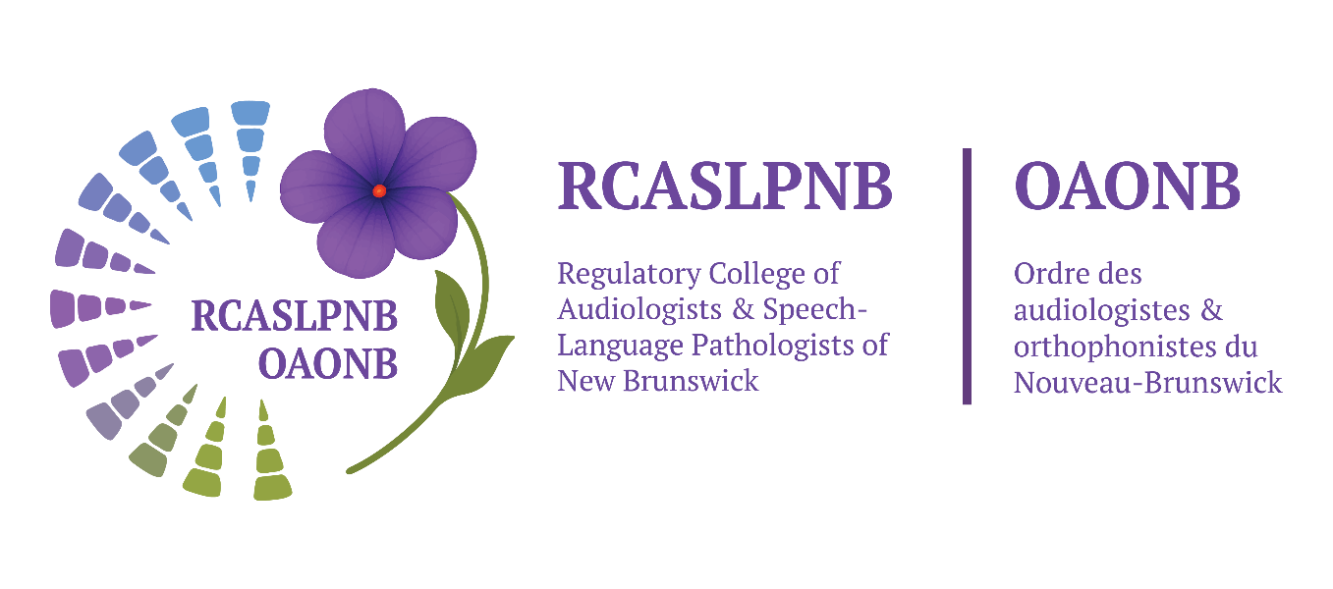

REGULATORY COLLEGE OF AUDIOLOGISTS &
SPEECH-LANGUAGE PATHOLOGISTS OF NEW BRUNSWICK

PO Box 23113 | Moncton, NB | E1A 6S8
Phone: (866) 455-9642 Fax: (866) 455-9642
info@rcaslpnb.ca www.rcaslpnb.ca
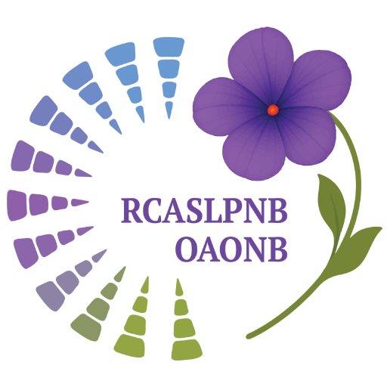
Coursework Summary Form - AUDIOLOGISTS

Use this form to summarize transcript information

Name: | Date:

Each semester hour of credit corresponds to 15 hours of lecture for theory-based courses or 30 hours of attendance at laboratory exercises.

Courses may be listed more than once, reflecting applicability of course content to satisfy academic requirements in more than one area. However, hours may be recorded and included only once in the Total Hours reported.

Please include the university course syllabus (in English) for all courses listed in this summary that were not completed at a Canadian Accredited University Program.

Section | Minimum Hours Required | Total Hours Reported
1 - Basic Knowledge Specific to the Profession | 135
2 - Basic Knowledge Related to Other Professions and Disciplines | 180
3 - Major Professional Area | 405
4 - Minor Professional Area | 45
TOTAL | 765

Section 1: Basic Knowledge Specific to the Profession: Normal Development and Use of Speech, Language and Hearing

Definition: Theory based courses designed to impart knowledge specific to client service in the area of human communication disorders. | Min Hours | Comments
 | 135 | - Undergraduate and graduate level courses accepted  - Note minimum required courses

Course Requirements:
I. Anatomical, physiological and neurological basis of speech, language and hearing functioning: Minimum 1 course required
- Examples: Anatomy and Physiology of Speech and Hearing; Introduction to Neurosciences for Communication Disorders; Neuroanatomy for Audiology and Speech-Language Pathology

Educational  Institution | Course Number | Course Name | Hours Completed

II. Physical basis and perceptual processes of hearing: Minimum 2 courses required

  - Examples: Hearing Science, Acoustics

Educational  Institution | Course Number | Course Name | Hours Completed
Section 1: Total Hours (135 Hours Minimum)

Section 2: Basic Knowledge Related to Other Professions or Disciplines

Definition: Theory based courses which include the study of other professions or disciplines, and deemed necessary in the area of human communication disorders. | Min Hours | Comments
 | 180 | - Undergraduate and graduate level courses accepted  - Note minimum required courses

Course Requirements:

I. Basic principles and methods involved in conducting research in human behaviour: Minimum 2 courses required
- Examples: Statistics; Research Methods
Edu. Institution | Course Number | Course Name | Hours Completed

II. Psychological and social aspects of human development: (Study must provide information from related fields) Minimum 1 course required
- Examples: Psychology; Education courses pertinent to communication disorders
- Study must include at least one of the following:
A. Theories of learning and behaviour that have application to communication disorder (verbal learning, behaviour modification, neuropsychology)
B. Study of personality development, abnormal behaviour (Abnormal psychology, Child development)
C. Study of development and education of special populations, psychometric evaluation, school psychology (human development in education)
D. Counselling and interviewing (counselling in communicative disorders)

Edu. Institution | Course Number | Course Name | Hours Completed

III. Professional practices and issues or administrative organization of audiology programs: Minimum 1 course required
- Examples: Professional issues; Principles of clinical practice

Edu. Institution | Course Number | Course Name | Hours Completed
Section 2: Total Hours (180 Hours Minimum)

Section 3: Professional Competencies, Specific to Audiology

Definition: Knowledge, skills and behaviours which are specifically applicable to the profession of Audiology | Min Hours | Comments
 | 405 | - Must be obtained at the graduate level unless coursework is determined to be ‘substantially equivalent’ by the Registration and Competence Committee.

Course Requirements:
I. Coursework must include development of competencies in each of the areas indicated:
Educational  Institution | Course Number | Course Name | Hours Completed
 |  | Hearing Measurement
 |  | Audiological Assessment
 |  | Electrophysiological and Other Diagnostic Measurement
 |  | Basic and Advanced Concepts in Amplification (Systems, Selection, Fitting, Verification, and Validation)
 |  | Implantable Hearing Devices
 |  | Calibration and Maintenance of Instrumentation
 |  | Auditory and Vestibular Disorders Involving Both Peripheral and Central Pathways of Hearing
 |  | Assessment and Management of Tinnitus, Including Hyperacusis
 |  | Paediatric Audiology
 |  | (Re)Habilitation Procedures Applied to Children, Adults, the Elderly, and Specific Populations (Developmental Delay, Occupational Hearing Loss)
 |  | Professional Practice Issues Specific to Audiology
Section 3: Total Hours (405 Hours Minimum)

Section 4: Professional Competencies, All Communication Disorders

Definition: Knowledge, skills, and behaviours which are applicable to the entire field of human communication disorders, and provides study in Speech-Language Pathology for Audiology majors | Min Hours | Comments
 | 45 | - Must be obtained at the graduate level unless coursework is determined to be ‘substantially equivalent’ by the Registration and Competence Committee.

I. Speech and language development, delays, and disorders:
- Examples
- Screening / identification programs and procedures for speech-language and hearing problems throughout the lifespan
- Potential impact of hearing loss on speech and language acquisition

Educational  Institution | Course Number | Course Name | Hours Completed
Section 4: Total Hours (45 Hours Minimum)

REGULATORY COLLEGE OF AUDIOLOGISTS &
SPEECH-LANGUAGE PATHOLOGISTS OF NEW BRUNSWICK

PO Box 23113 | Moncton, NB | E1A 6S8
Phone: (866) 455-9642 Fax: (866) 455-9642
info@rcaslpnb.ca www.rcaslpnb.ca
Coursework Summary Form - SPEECH-LANGUAGE PATHOLOGISTS

Use this form to summarize transcript information

Name: | Date:

Each semester hour of credit corresponds to 15 hours of lecture for theory-based courses or 30 hours of attendance at laboratory exercises.

Courses may be listed more than once, reflecting applicability of course content to satisfy academic requirements in more than one area. However, hours may be recorded and included only once in the Total Hours reported.

Please include the university course syllabus (in English) for all courses listed in this summary that were not completed at a Canadian Accredited University Program.

Section | Minimum Hours Required | Total Hours Reported
1 - Basic Knowledge Specific to the Profession | 135
2 - Basic Knowledge Related to Other Professions and Disciplines | 180
3 - Major Professional Area | 405
4 - Minor Professional Area | 45
TOTAL | 765

Section 1: Basic Knowledge Specific to the Profession: Normal Development and Use of Speech, Language and Hearing

Definition: Theory based courses designed to impart knowledge specific to client service in the area of human communication disorders. | Min Hours | Comments
 | 135 | - Undergraduate and graduate level courses accepted  - Note minimum required courses

Course Requirements:

I. Anatomical, physiological and neurological basis of speech, language and hearing functioning: Minimum 1 course required
- Examples: Anatomy and Physiology of Speech and Hearing; Introduction to Neurosciences for Communication Disorders; Neuroanatomy for Audiology and Speech-Language Pathology

Educational  Institution | Course Number | Course Name | Hours Completed

II. Fundamental information pertaining to the use of speech and language processes: Minimum 2 courses required

  - Examples: Linguistics; Psycholinguistics; Normal Acquisition of Speech and Language; Phonetics; Phonology

Educational  Institution | Course Number | Course Name | Hours Completed
Section 1: Total Hours (135 Hours Minimum)

Section 2: Basic Knowledge Related to Other Professions or Disciplines

Definition: Theory based courses which include the study of other professions or disciplines, and deemed necessary in the area of human communication disorders. | Min Hours | Comments
 | 180 | - Undergraduate and graduate level courses accepted  - Note minimum required courses

Course Requirements:

I. Basic principles and methods involved in conducting research in human behaviour: Minimum 2 courses required
- Examples: Statistics; Research Methods
Edu. Institution | Course Number | Course Name | Hours Completed

II. Psychological and social aspects of human development: (Study must provide information from related fields) Minimum 1 course required
- Examples: Psychology; Education courses pertinent to communication disorders
- Study must include at least one of the following:
A. Theories of learning and behaviour that have application to communication disorder (verbal learning, behaviour modification, neuropsychology)
B. Study of personality development, abnormal behaviour (Abnormal psychology, Child development)
C. Study of development and education of special populations, psychometric evaluation, school psychology (human development in education)
D. Counselling and interviewing (counselling in communicative disorders)

Edu. Institution | Course Number | Course Name | Hours Completed

III. Professional practices and issues or administrative organization of speech-language pathology programs: Minimum 1 course required
- Examples: Professional issues; Principles of clinical practice

Edu. Institution | Course Number | Course Name | Hours Completed
Section 2: Total Hours (180 Hours Minimum)

Section 3: Professional Competencies, Specific to Speech-Language Pathology

Definition: Knowledge, skills and behaviours which are specifically applicable to the profession of Speech-Language Pathology | Min Hours | Comments
 | 405 | - Must be obtained at the graduate level unless coursework is determined to be ‘substantially equivalent’ by the Registration and Competence Committee.

Course Requirements:
I. Coursework must include development of competencies in each of the areas indicated:
Educational  Institution | Course Number | Course Name | Hours Completed
 |  | Articulation / Phonological Disorders
 |  | Preschool / School-Aged Language Development and Literacy
 |  | Development Language Disorders
 |  | Acquired Language Disorder
 |  | Cognitive Communication Disorder
 |  | Voice Disorders
 |  | Resonance Disorders or Structurally Related Disorders (Cleft Lip and Palate)
 |  | Fluency Disorders
 |  | Neurologically Based Speech Disorders
 |  | Augmentative and Alternative Communication
 |  | Dysphagia
 |  | Professional Practice Issues Specific to Speech-Language Pathology
Section 3: Total Hours (405 Hours Minimum)

Section 4: Professional Competencies, All Communication Disorders

Definition: Knowledge, skills and behaviours which are applicable to the entire field of human communication disorders, and provides study in Audiology for Speech-Language Pathology majors | Min Hours | Comments
 | 45 | - Must be obtained at the graduate level unless coursework is determined to be ‘substantially equivalent’ by the Registration and Competence Committee.

I. Development of normal hearing, hearing disorders and related speech-language disorders:
- Examples
- Symptoms of hearing disorders including associated speech, language and voice profiles
- Screening procedures and basic audiometric testing
- Application of audiometric information to the speech-language assessment
- Modification in speech and language procedures to accommodate varying degrees of hearing loss
- Approaches to habilitation and rehabilitation of speech and language of the hearing impaired
- Use, care and maintenance of hearing aids, assistive listening devices, and amplification systems

Educational  Institution | Course Number | Course Name | Hours Completed
Section 4: Total Hours (45 Hours Minimum)

